

**ASPECT BASED SENTIMENT ANALYSIS USING BERT**

**by**

**Srija Piralta**

**Instructor**

**Dr. Marek Reformat**

A program project submitted in partial fulfillment of the requirements of the degree of

**Master of Engineering(M.Eng)**

**in**

**DEPARTMENT OF ELECTRICAL AND COMPUTER ENGINEERING**

(Software and intelligence systems)

**CONTENTS**

**ABSTRACT………………………………………………………………………. 3**

1. **INTRODUCTION……………………………………………………………. 4**
2. **SENTIMENT ANALYSIS…………………………………………………… 5**
3. **ASPECT BASED SENTIMENT ANALYSIS………………………………. 7**
4. **BERT…………………………………………………………………………... 8**
5. **DATASET……………………………………………………………………... 10**
6. **METHODOLOGY…………………………………………………………….10**
7. **RESULTS……………………………………………………………………... 16**
8. **FUTUREWORK……………………………………………………………… 19**
9. **CONCLUSION……………………………………………………………...... 19**

**REFERENCES………………………………………………………………......... 21**

# ABSTRACT

Sentiment analysis is a tool widely used by organizations to understand the general opinion of consumers of their product and services. It helps organizations to take decisions based on the polarity of the audiences towards their products. Aspect based sentiment analysis (ABSA) is one of the sentiment analysis techniques employed by businesses to understand the consumer opinion of a certain attribute of their product or service instead. This will help businesses to choose aspects that are desirable to the consumers. However, this is a complex task to achieve.

BERT is one of the machine learning techniques used to perform ABSA. This report explains in detail the architecture of BERT. In order to do this, we look at the laptop reviews provided by the users. This project presents the study of how the Aspect-based sentiment analysis is performed using the pre-trained language model BERT. The behaviour of model predictions is explained using the component called professor, which helps to observe how the model predicted the sentiment for a particular aspect. The results and performance of the Aspect based sentiment analysis model are analysed using the confusion matrix and presented in the report.

# INTRODUCTION:

A business has hundreds or thousands of reviews across various sites to retrieving them manually for sentiment is time-consuming. To be effective for the businesses we need to start looking for AI-powered review sentiment analysis to review the insights quickly and precisely. In product review, sentiment analysis API is used to find the insights and to find relationships with your text data. Three steps are performed. Data gathering is where you gather and prepare the data that you want to analyze whether it is internal or external data. In order to prepare the data for the text analysis, we need to put it into a CLS document format. Apply review sentiment analysis API where you run your input data. It will immediately return the relevant topic or any aspect that is ranging from -1 for negative emotions and 0 for neutral and 1 for positive emotions. Sentiment Analysis Dashboards is sentiment scoring where you use different data Visualization and power BI tools to return the data into visual reports and the made-up charts, graphs insights the data.

Online Review sentiment analysis helps the business to identify and extract how the customers feel about the business and classify the feelings, easy to visualize customer insights for the fast analysis. It is Accurately used to target operational improvements at the problem areas. It is to create sentiment metrics baseline that is used to measure the change progress. In a business, review insights are used to draw from. This trick is to embrace the good with the bad. Instead of considering the negative reviews, we can use them when we turn around the business areas that needed to be tuned. By this, you can not only see the profitability you can use better brand perception as customers realize that they are listening to them. To take a step further you can build a more meaningful relationship with your customers and enhance their status online. The reviews are more authentic when the online community and product reviews can be for both customer and the employee.

# SENTIMENT ANALYSIS

Sentiment analysis is a process in which the algorithm identifies the contextual meaning of a text. It is primarily used by businesses to understand the consumer’s opinion of their products and services. Sentiment analysis is widely used in industries such as e-commerce, marketing, advertising, market research etc., (Tom, 2021). It helps businesses in an efficient manner to determine if audiences conceive their products in a positive, negative or a neutral way. This information is critical for organizations to decide either to improve or sustain their service (Tom, 2021).

**Figure 2.1 Sentiment Analysis** (Symeonidis)

Developers create a text machine-learning-based algorithm that will detect the contents to show any specific sentiment indicator. After that, they train the Machine learning classifier to feed a huge quantity of training datasets (Cogito, 2021). Sentiment analysis works by breaking down the text into its component parts. It then identifies sentiment bearing phrases and components in the text and assigns a score sourced from the sentiment library (Lexalytics, n.d.).

Sentiment analysis can be tailored to serve the purpose of the organizations. Some of the sentiment analysis that are most popularly used are ‘fine-grained sentiment analysis to determine the polarity of the audiences, ‘emotion-detection’ to perceive the emotions of consumers towards a product or service, and ‘aspect-based sentiment analysis to identify the opinion of a particular attribute of the commodity (Lexalytics, n.d.).

The types of sentiment analysis are

**1) Fine-grained sentiment:** It is one of the simplest ways to understand customers' sentiments. It helps to study the ratings and reviews given by the customers. To analyze the sentiments that can use the readily available categories providing rating opinion that feedback given by the customer. Most e-commerce sites use this technique to know the sentiments of the customers.

**2) Intent-based sentiment Analysis:** It is used to know the intent of the customer that is looking to buy whether the product or just to browse around to achieve it through intent analysis. It saves their time, effort, and cost while targeting the potential customers as per their intentions.

**3) Emotion Detection Sentiment Analysis:** It helps to understand the emotions of the people like anger, sadness, happiness, frustration, fear. Emotion detection is more difficult as people use a collection of words to have a different sense of meaning (Cogito, 2021).

It is a very difficult task due to sarcasm. It comes with a different sense of meaning depending on the sender's situation. Most common behavior on social media you can see interfering with the results. It shows the unique behavior of the people. These caustic remarks can easily mislead the sentiment analysis decisions (Cogito, 2021).

# ASPECT BASED SENTIMENT ANALYSIS

With the advancement of technology, majority of people have taken social media as their platform to express opinion on various aspects of products. This information is valuable to organizations, researchers, and businesses to determine the audience’s polarity towards a particular aspect of the product. This process of identifying aspects and their sentiment is called Aspect Based Sentiment Analysis (ABSA).

The objective is to predict the sentiment polarity for each identified topic and the associated aspect. This type of sentiment analysis is focused on the aspects of a particular product or service. To make it clear to understand, let's take an example – if you are talking about Bluetooth speaker. Here you can analyse your customer's sentiments by asking them for feedback about the sound quality, battery usage, and other features, making such devices more productive for the users. It helps in determining specific attributes of the product [6].

The ABSA can divide into two, aspect category and aspect term. Aspect category analysis is a coarse-grained level of identifying of aspects and the following one is a bit fine-grained level of extraction of the same. An example of aspect category sentiment Analysis is movies, music, etc. While drama, Horror, drums etc. are examples of aspect term Sentiment Analysis.

One of the main advantages of ABSA is its scalability. Because ABSA can easily analyse the textual data, automatically at a fine-grained level. Aspect-based sentiment analysis will be analysing aspects in texts like reviews, comments, etc., so that the companies or people can concentrate on those particular aspects where their customers are complaining or providing suggestions to improve their product or service. This will save a huge amount of time and money for the companies or individuals.

1. **BERT**

Bidirectional Encoders Representation from Transformers (BERT) developed by Google is an open-source machine learning technique used for Natural Language Processing (NLP) pre training (Horev, 2018). It establishes the context in an unclear sentence by using the surrounding text and produces better results for search queries (Lutkevich, 2020) (Schwartz, 2019). BERT is capable of analysing a given text bi-directionally as opposed to other historical NLP techniques that look through text only in one direction (Horev, 2018). This will help the computer understand the context of a given sentence and eventually produce accurate results. To accomplish this, BERT uses two techniques: Masked Language Model (MLM) and Next Sentence Prediction (NSP) (Horev, 2018).

In MLM, the program masks 15% of the words with mask tokens, tries to understand the context based on other words in the text and ultimately predicts the masks words (Horev, 2018). This is accomplished by deploying a classification layer on top of the input sequence. The input sequence is then fed into BERT resulting in output logits. A SoftMax function is used to obtain a probability distribution followed by argmax function to obtain the required token id. The token id is sent through a tokenizer to get the actual masked word based on the context derived from surrounding unmasked words.

In NSP, the program predicts the relationship between two sentences that are inputted (Lutkevich, 2020) i.e., if the second sentence is in sequence to the first sentence or not. This is done by adding a CLS token at the start of first sentence and a SEP token at the end of each sentence of input sequence. The input sequence then goes through the feed forward neural network resulting in 2 outputs. An argmax function is then used to get the desired output of either 0 or 1.

To feed the review text data as input to the model. we need to follow a few preprocessing steps that are to be implemented.

a) Canonicalization: Here initially, the numerical punctuation marks, special characters are ignored, and the existing uppercase letters are converted to the lower-case letters

b) Tokenization: By segregating the input reviewed text data into a certain format. Workpiece tokenization is used to handle the terms that are not present in the glossary. It splits the word text into a sub word or root word (M.P. Geetha, 2021).

**Figure 4.1: BERT Contextualize Embeddings Architecture**

It is an encoder stack to transform architecture and an encoder-decoder network that is used for self-attention on the encoder side and attention on the decoder side. The 12 layers are in the Encoder stack while the Bert large has 24 layers in the encoder stack. It takes the CLS token as input and then is followed by a sequence of words as input. CLS classification token passes the input to the above layers and each layer applies self-attention that passes the result through a feedforward network it hands off to the next encoder.

1. **DATASET:**

ABSA techniques are performed on the same dataset that they are developed. One of the frequently used ABSA datasets was released in the SemEval2016 challenge. The dataset contains laptop reviews from all over the world in English. The reviews were written during the period between 2009 to 2018.From these reviews, we randomly selected 3412 samples. The reviews are annotated with the SemEval2016 annotation guidelines for the laptop domain [5]. Each review contains an aspect term that is the aspect used in the text to refer to the reviewed entity. The aspect target is null if the aspect is implicit. These reviews consist of the polarities associated with the aspect term. The data is in XML format. The below figure shows the snippet of the data.



**Fig 5.1: Data snippet for the reviews**

1. **METHODOLOGY:**

The extraction of sentiment based on the aspect follows different steps. The below-mentioned figure shows the workflow for the extraction of sentiment. Each step in the work flow is crucial for the extraction of polarity.

**Fig 6.1: Work flow for the Sentiment Extraction**

**Data Pre-Processing:**

Extracting the polarity of sentiment analysis contains many steps. Several methods are used for the extraction of polarity based on the aspect. This is explained in the below diagram.

The data we consider here is in XML format. The data is extracted into the data frame using the XML parser in Python. Id, Review and aspect are the required columns that are extracted into the data frame. In order to extract the data into the data frame, we use multiple frames, and then it is merged to extract all the required columns. Id, review, aspect are the final attributes used in the data frame. The data preprocessing involves many steps. The Null and NA values are filtered from the data frame. The duplicate records are removed from the data frame. If the correlation between aspect and the review is null then the respective records are removed from the data frame.

**Tokenization:**

None of the Deep learning models can work directly with the text. It needs to be converted into numbers or the format which the model can understand. Tokenization plays a crucial role in NLP as it helps convert the text to numbers which deep learning models. Bert is based on transformer architecture and is presently one of the best methods in NLP. To feed the reviews to the model the reviews should be converted to tokens.

The input representation in BERT follows a process based on the tasks. The tasks are of two types Classification and Next sentence prediction task. The BERT tokenization converts the reviews into tokens as explained in chapter 5 [13].

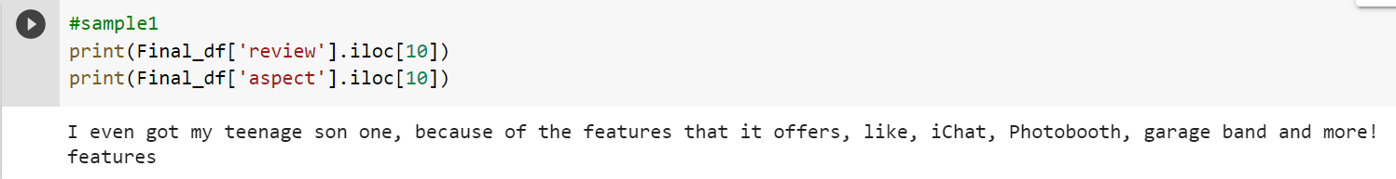

**Fig 6.1: Sample review and aspect from the data set**

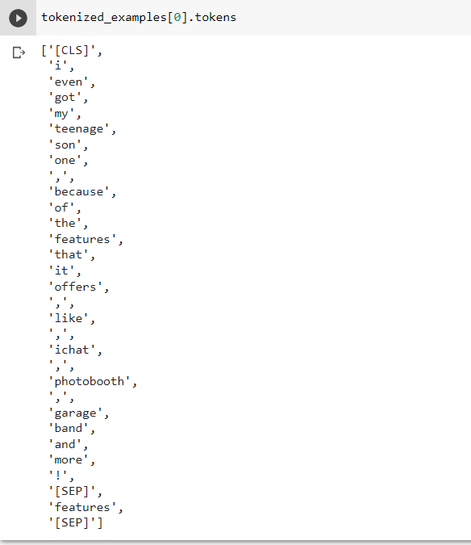

**Fig 6.2: Output after Tokenization of the sample review**

The BERT tokenization forms a sequence pair by adding the aspect at the end of the review. [CLS] token is appended at the start of the review. [SEP] token is added at the end of the review. The tokenized output is fed to the encoder.

**Encoding:**

The encoding is performed after tokenization. The tokens obtained above are encoded. The encoding is performed by the transformer. Different transformers are used for encoding. Here in this project, BERT transformer is considered. It is widely used in various NLP processes. Usually, encoders in the transformers read the input sentence and decoders predict the output sentence. The bi-directional in BERT comes from the fact that it reads all the input terms simultaneously. The BERT understands the input sentences and generates some input features that can be used for the model [13].

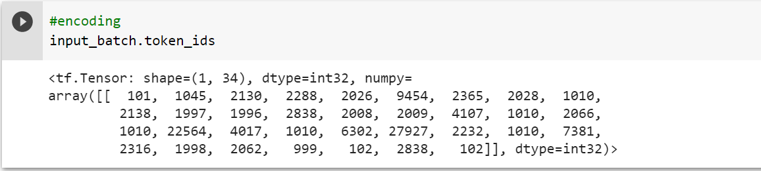

**Fig 6.3: Output after Encoding of the sample review**

The above screenshot represents the encoded values for the tokenized output shown in the figure. The tokenized inputs are taken as input to the encoder and it provides the encoded values. The encoded values are fed as input to the model.

**Model:**

The pre-trained BERT model is used to predict the sentiments of the reviews based on the aspects. The aspect-based sentiment analysis package helps to use the pre-trained BERT Model. The review and aspect are passed as are arguments to the model. Similarly, this process is performed for all the reviews and aspects obtained after pre-processing the data. The leverage of functions and lambda functions in python helps to implement the model easier.

**Supervision:**

The ABSA package has a component professor whose main feature is to demonstrate the model reasoning. Model transparency enables us to understand whether the model fails from various viewpoints such as safety and reliability.

To explain this model decision is difficult due to model complexity. Different people have a way to understand decisions. To translate the abstract model reasoning that is understandable for humans. Breakdown of the model reasoning is mandatory to understand and, these are known as patterns. A pattern rating attribute which is <0,1> describes how to contribute to the model prediction. The aspect-based sentiment classifier, model is based on the transformer architecture in which the self-attention layer holds the most useful parameters. It can conclude that understanding self-attention layers is only a good process to understand [12].

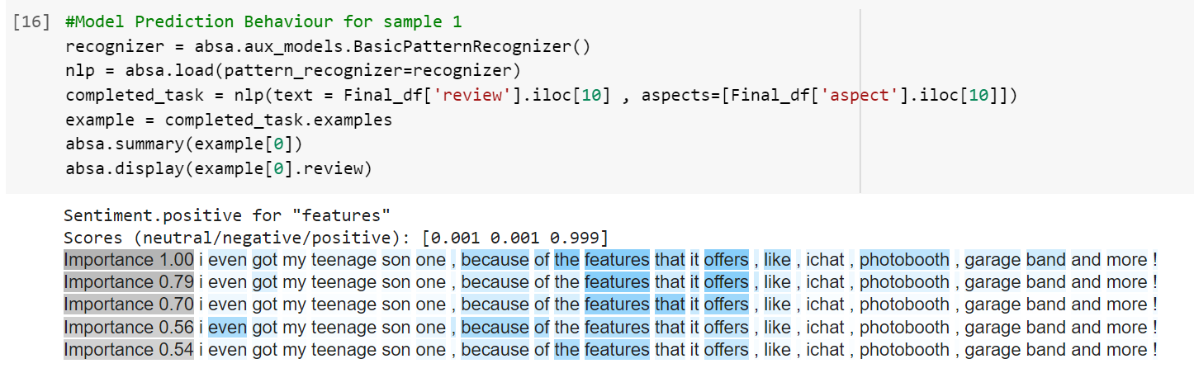

**Fig 6.4: Example of Supervision for the sample review**

The above figure shows the example of a pattern recognizer that identifies the model decision based on its importance. In the above figure, the sentiment positive is assigned to the model based on the key token’s features. The key tokens are highlighted (bright to light) as in the above figure. Since the keywords are positive terms and the sentence provides a positive explanation, the model predicted the sentiment as positive. The model predicts the sentiment for each review. The sentiment is stored in a new column corresponding to the review and the aspect.

**Post-Processing:**

In the NLP component of the model, the review and aspect of the dataset are passed as the arguments. The pre-trained model predicts the sentiment of the review. The process is performed to the data set that is achieved after pre-processing.

The ‘Calculated Sentiment’ is used to store the predicted sentiment from the model. The calculated sentiment is compared with the actual sentiment to get the accuracy of the model. The integers are mapped to the corresponding sentiments to get it in the string format. The below figure shows the calculated sentiment predicted by the Model. The calculated sentiment is mapped to the original values to be understood by the humans [12]

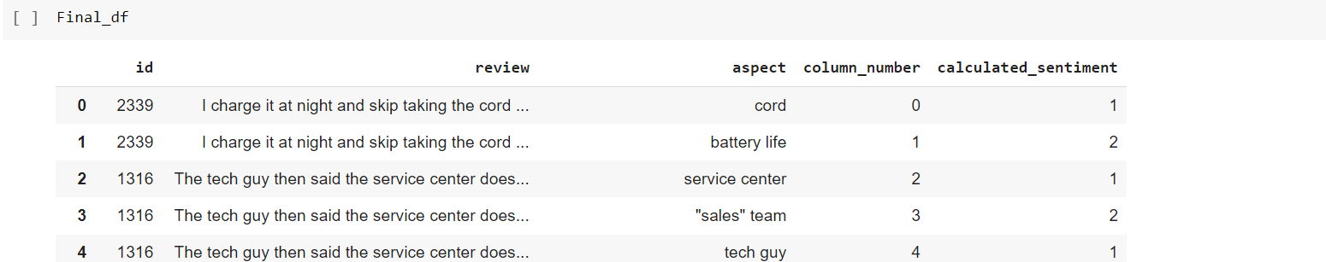

**Fig 6.5: Data frame after prediction of the sentiment**

1. **RESULTS**

Polarity extraction of the reviews is performed on the dataset that is mentioned in chapter4. To extract the polarity, it undergoes several steps. The below figure shows a sample of the review and aspect of purchased laptops feedback provided by the customers.

**Fig 7.1: Sample Review and Aspect**

Tokenization and encoding are performed for the respective review as it is the basic step to provide the inputs in the Natural language model (NLP). The Tokenization and, encoded values of the sample that is considered is mentioned in the below figure.

**Fig 7.2: Tokenization and Encoding of Sample Review**

To extract the sentiment for the review, the tokenized and encoded values are fed as input to the model. The given model is based on the aspect and the below figure represents the sample of the sentiment that is extracted from executing the model. The model has assigned the sentiment positive for the sample that we have considered because of the keywords incredible and satisfied. Hence the model assigned the highest score to the positive sentiment.

**Fig 7.3: Sentiment extraction for the sample review**

To explain the model behavior, we have a professor component. It shows how a particular sentiment for the sample is predicted. The below figure shows how the model assigned positive sentiment to the review. It is based on the keywords that are highlighted and the important rating is given.

**Fig 7.4: Model prediction for the sample review**

Confusion matrix and accuracy metrics are used to calculate the performance of the model. The below figure gives the confusion matrix and accuracy score of the dataset considered. Based on the confusion matrix the accuracy score is calculated. The accuracy score for the given model is 66.3%.

**Fig 7.5: Confusion Matrix of the Model**

**Fig 7.6: Accuracy score of the Model**

# FUTURE WORK

This study is limited to the dataset provided. This can be further extended to extract aspects from texts and online product reviews in the future using other fine-tuning BERT strategies. The aspect-based sentiment analysis is implemented for the dataset and, also a comparison of the performance metrics is limited. We can improve the work by using various possible methods. Multi-word clustering in vector representation for multi-words may help to enhance various methods is based on the pre-trained BERT model. This may include the higher performance of the post-training BERT.

1. **CONCLUSION**

Sentiment Analysis identifies and extracts useful information for the business to understand the sentiments. Opinions, feelings, emotions are significant in this modern world. Aspect-based Sentiment Analysis is one of the sentiment analysis that is used to identify the sentiment which is related to each aspect. Basically, it is used to categorize the opinions by aspect. The drawback of the Aspect-based sentiment Analysis is due to the lack of benchmark datasets and that are available for only a few domains. Natural language methods and deep learning used in aspect-based sentiment analysis gave some favorable results. In this report, the implementation of the Aspect-based sentiment analysis using BERT uses a dataset related to laptops for sentiment extraction. The aspect-based sentiment analysis package is used for the implementation of Aspect-based Sentiment Analysis. The package uses NLP and deep learning methods using BERT for extraction of Sentiment. The leverage of using the package is model behavior for the predicted sentiment can be known by a component called professor. The accuracy is 66.2% for the laptop domain which is used in this report. The more research is being conducted in this field which helps to achieve better results.

**REFERENCES:**

[1] Tom, "Brand24," 13 02 2021. [Online]. Available: <https://brand24.com/blog/sentiment->analysis/. [Accessed 20 12 2021].

[2] S. Symeonidis, "Sentiment Analysis Classification," [Online]. Available: https://www.kdnuggets.com/2018/03/5-things-sentiment-analysis-classification.html. [Accessed 12 2021].

[3] Cogito, "Cogito Tech," 01 03 2021. [Online]. Available: https://www.cogitotech.com/blog/sentiment-analysis-types-how-it-works-why-difficult. [Accessed 20 12 2021].

[4] Lexalytics, "Lexalytics," [Online]. Available: https://www.lexalytics.com/technology/sentiment-analysis. [Accessed 20 12 2021].

[5] S. Consultants, "Github," Github, [Online]. Available: https://github.com/ScalaConsultants/Aspect-Based-Sentiment-Analysis. [Accessed 12 2021].

[6] A. S. I. A. K. ZENUN KASTRATI, "Weakly Supervised Framework for Aspect-Based Sentiment Analysis on Students' Reviews of MOOCs," IEEE Access, vol. 8, pp. 106799 - 106810, 2020.

[7] R. Horev, "BERT Explained: State of the art language model for NLP," 10 11 2018. [Online]. Available: https://towardsdatascien* ce.com/bert-explained-state-of-the-art-language-model-for-nlp-f8b21a9b6270.

[8] B. Lutkevich, "Tech Target," 30 01 2020. [Online]. Available: https://www.techtarget.com/searchenterpriseai/definition/BERT-language-model. [Accessed 20 12 2021].

[9] B. Schwartz, "Search Engine Land," 25 10 2019. [Online]. Available: https://searchengineland.com/welcome-bert-google-artificial-intelligence-for-understanding-search-queries-323976. [Accessed 12 2021].

[10] D. K. R. M.P. Geetha, "Improving the performance of aspect based sentiment analysis usingfine-tuned Bert Base Uncased model," International Journal of Intelligent Networks, vol. 2, pp. 64-69, 2021.

[11] G. f. Geeks, "Explanation of BERT Model – NLP," 03 05 2020. [Online]. Available: https://www.geeksforgeeks.org/explanation-of-bert-model-nlp/. [Accessed 20 12 2021].

[12] “Do you trust in aspect-based sentiment analysis? Testing and explaining model behaviors,” Rafalrolczynski.com. [Online]. Available: https://rafalrolczynski.com/2021/03/07/aspect-based-sentiment-analysis/. [Accessed: 13-Dec-2021].

[13] “BERT - Tokenization and Encoding,” Github.io. [Online]. Available: https://albertauyeung.github.io/2020/06/19/bert-tokenization.html/.